- GPIO accessing in LPC2148:
lpc2148 has two I/O ports,
PORT0 and PORT1
PORT0 (P0.0 to P0.31) among these P0.24 ,P0.26,P0.27 are reserved pins
PORT1 (P1.16 to P1.31)
Q) How many I/O pins in LPC2148?
ANS) 45 I/O pins

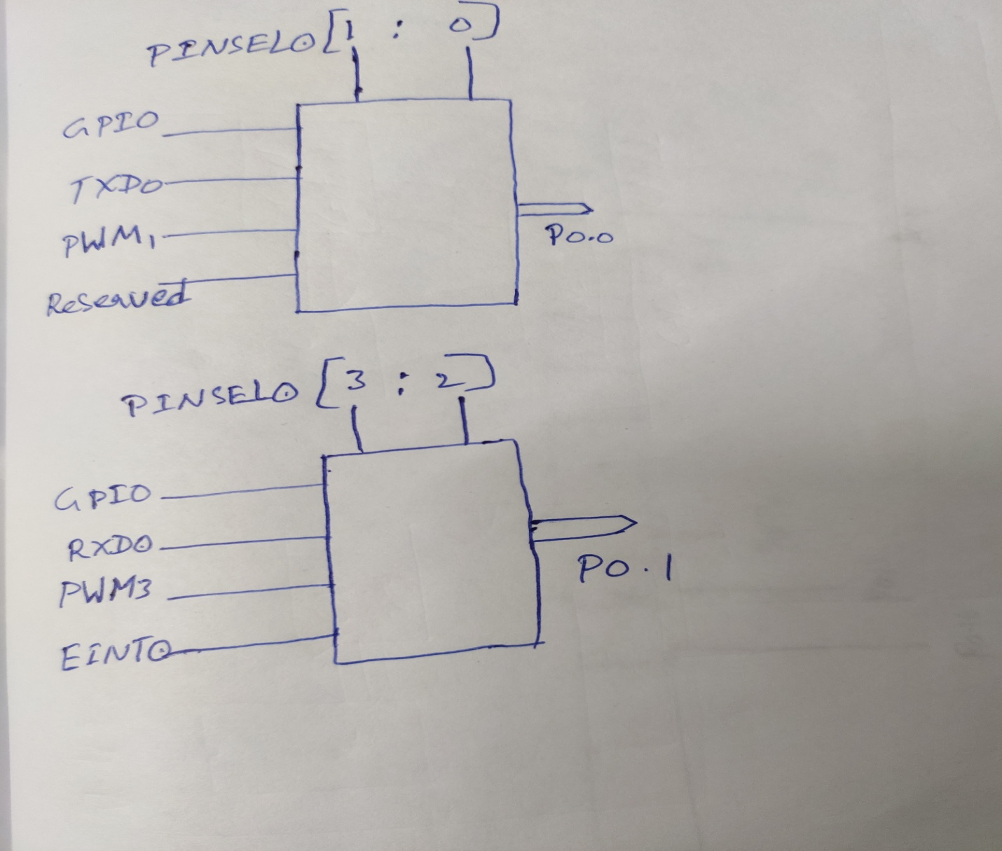

- Pin functionalities are selected by using PINSEL registers(PINSEL0,PINSEL1,PINSEL2)
- By default all the pins acts as GPIO’s
- Registers to access GPIO’s in LPC2148:
PORT0:
IODIR0
IOSET0
IOCLR0
IOPIN0

PORT1:
IODIR1
IOSET1
IOCLR1
IOPIN1

Example1:
Select P0.0 as GPIO fucntionality ,set the direction as output pin and write Logic 1
and then write Logic 0 to the port pin.
ans)
- PINSEL0 = 0X00000000;//P0.0 to P0.15 AS GPIO’s
- IODIR0 = 0X00000001;//P0.0 as OUTPUT pin rest of the pins as INPUTS
- IOSET0 = 0X00000001;//write LOGIC 1 to P0.0 and no effect on the bits which are zero
- IOCLR0 = 0X00000001;//write LOGIC 0 to P0.0 and no effect on the bits which are zero
Example2 :
select P0.3 as GPIO functionality ,set the direction as output pin and write Logic 1
and then write logic 0 to the port pin.
ans)
- PINSEL0 = 0X00000000;//P0.0 TO P0.15 AS GPIO’S
- IODIR0 = 0X00000008;//P0.3 AS OUTPUT pin
- IOSET0 = 0X00000008;//Write Logic 1 to P0.3
- IOCLR0 = 0x00000008 ;//write Logic 0 to P0.3

Example3:
Select P0.2 ,P0.3,P0.5 as GPIO’s ;Set the direction of the pins as Output pins;
And write Logic 1 to the port pins and then write Logic 0 to the port pins.
Ans:
- PINSEL0 = 0X00000000;//P0.0 TO P0.15 AS GPIO’S
- IODIR0 = 0X0000002C;//P0.2,P0.3 and P0.5 AS OUTPUT pin
- IOSET0 = 0X0000002C;//Write Logic 1 to P0.2,P0.3 and P0.5
- IOCLR0 = 0x0000002C ;//write Logic 0 to P0.2,P0.3 and P0.5

